

|  |  |
| --- | --- |
| **Intake: APD1F2409CS(CYB)** | **Module Code: CT109-3-1-DGTIN** |

|  |  |  |
| --- | --- | --- |
| **HAND OUT DATE: Week 1 Monday, 7th October, 2024** |  |  |
| **SUBMISSION DATE: Week 10, Friday 20th December, 2024** |  |  |

**TITLE:**

***EVERGRANDE REAL ESTATE COMPANY***

**Module Lecturer: HAIRUL AYSA ABDUL HALIM SITHIQ**

**GROUP REAL ESTATE**

|  |  |  |
| --- | --- | --- |
| **AHMED MIRAHUSAIN ALVI** | | **TP084807** |
| **ABDALLAH MOHAMED MAHMOUD MOHAMED** | | **TP085097** |
| **HANSEN NICHOLAS CAN** | | **TP075390** |
| **ARCHIE NICHOLAUS YIEDRI** | | **TP081430** |
| **JONATHAN LILIO SAPUTRA** | | **TP078746** |
| **MOHAMED ABDIFATAH ALI** | | **TP082459** |
| **MOHAMMED YOUSEF MOHAMMED MOHAMMED** | | **TP085042** |
| **MAHRUS SHAMSUL AHSAN** | | **TP085562** |
| **ANDREW WIJAYA** | | **TP079319** |
| **JONATHAN CHRISTIAN LENGKONG** | | **TP079992** |
| **LIM QUAN TAI** | | **TP080629** |
| **ALAJMANI SALAH WADEEA SHAMSAN** | **TP083015** | |

**Table of Contents**

**ACKNOWLEDGEMENT…………………………………………………………………...1**

**ABSTRACT…………………………………………………………………………………..2**

**INTRODUCTION……………………………………………………………………………3**

**CHAPTER 1: LACK OF AI INTEGRATION AND PERSONALIZATION**

**1.1 ISSUE……………………………………………………………………………..4**

**1.2 SOLUTION……………………………………………………………………….5**

**1.3 PROTOTYPE…………………………………………………………………...10**

**CHAPTER 2: OUTDATED DESIGN**

**2.1 ISSUE…………………………………………………………………………....14**

**2.2 SOLUTION……………………………………………………………………...18**

**2.3 PROTOTYPE…………………………………………………………………...20**

**CHAPTER 3: LIMITED SEARCH FUNCTIONALITY**

**3.1 ISSUE……………………………………………………………………………23**

**3.2 SOLUTION………………………………………………………………...........25**

**3.3 PROTOTYPE…………………………………………………………………...28**

**CHAPTER 4: ABSENCE OF MORTGAGE CALCULATOR**

**4.1 ISSUE…………………………………………………………………………....29**

**4.2 SOLUTION……………………………………………………….......................31**

**4.3 PROTOTYPE…………………………………………………………………...36**

**CHAPTER 5: LACK OF VISUALIZATION FEATURES**

**5.1 ISSUE…………………………………………………………………………....39**

**5.2 SOLUTION……………………………………………………………………...40**

**5.3 PROTOTYPE…………………………………………………………………...44**

**CONCLUSION……………………………………………………………………………...47**

**REFERENCES……………………………………………………………………………...48**

**APPENDIX B: WORK BREAKDOWN STRUCTURE……………………………...….51**

**ACKNOWLEDGEMENT**

I would like to extend my heartfelt gratitude to everyone who supported and contributed to the successful completion of this assignment. First and foremost, I am deeply appreciative of my mentor, Ms. Hairul Aysa Abdul Halim Sithiq, for her invaluable guidance and insightful feedback throughout this process. Her support and constructive critiques were instrumental in shaping both the direction and quality of this work. I am also sincerely grateful to my colleagues and peers, whose ideas and collaborative efforts enriched our understanding of the subject matter. A special note of thanks goes to my friends: Archie Nicholaus Yiedri, Jonathan Lilio Saputra, Mohamed Abdifatah Ali, Mohammed Yousef Mohammed, Mahrus Shamsul Ahsan, Ahmed Mirahusain Alvi, Andrew Wijaya, Jonathan Christian Lengkong, Lim Quan Tai, Hansen Nicholas Can, Alajmani Salah Wadeea Shamsan, and Abdallah Mohamed Mahmoud Mohamed for their unwavering encouragement and cooperation during this endeavour. Finally, I would like to acknowledge the numerous sources, including books, articles, and online materials, that informed and enhanced our research. Their accessibility played a critical role in enabling us to complete this task successfully. Thank you all for your support, contributions, and belief in us throughout this journey.

**ABSTRACT**

This paper explores the key aspects of the Evergrande real estate company's website and proposes solutions and prototypes to enhance the user experience. The analysis is structured into five chapters. Chapter 1 investigates the absence of AI integration and personalization, highlighting the lack of smart systems to improve customer engagement. Chapter 2 critiques the outdated design principles, advocating for a more modern aesthetic. Chapter 3 addresses the limitations of the current search capabilities and suggests more customizable and adjustable query solutions. Chapter 4 discusses the lack of a mortgage calculator and proposes an alternative to increase usability for the target audience. Chapter 5 examines the absence of 3D virtual tours and recommends new design templates to enhance customer experiences. The paper provides recommendations and design sketches to address these issues and concludes with insights into the potential impact of these improvements on the future of Evergrande.

**INTRODUCTION**

Evergrande Real Estate was founded in 1996 by Hui Ka Yan, a former Chinese billionaire who served as the chairman of Evergrande Group. The company is headquartered in Nanshan District, Shenzhen, though there were plans to relocate the headquarters to reduce costs. Evergrande Real Estate Group has over 1,300 projects in more than 280 cities in China, dedicated to creating high-quality and cost-effective boutique communities for proprietors.

In 2021, Evergrande's mounting debt obligations causing a crisis in China's property sector. The company's total debts were estimated to be in the hundreds of billions of dollars, contributing to a significant drop in many stock market indices on 20 September 2021.

By the end of 2021, the Chinese government reportedly began working on restructuring Evergrande to address the crisis. Additionally, on 7 January 2022, the group sought approval from its bondholders for a moratorium on the early repayment option for one of its yuan-denominated bonds.

Evergrande stated on 19 March 2024 that the China Securities Regulatory Commission (CSRC) had found that the company had overstated its revenue in 2019 by 214 billion yuan or about half of it, and in 2020 its revenue was overstated by nearly 80%, or 350 billion yuan The China Securities Regulatory Commission also suspected problems with the bonds Evergrande issued. The regulator fined Evergrande 4.2 billion yuan for falsifying its revenue, among other financial misconduct.

We chose this company because the lack of care the company gives to the user. Causing their services that they are offering are poor. Missing many key components that other real estate company can offer. Other than missing features, their website are also slow. This is because of poor maintenance and not many attentions put into it, making the experience weaker than other companies competing in the real estate field. With this chance, we want to find out ways and solutions to fix the flaws of the company.

(Amaranth, 2024)

**CHAPTER 1:  
 LACK OF AI INTEGRATION & PERSONALIZATION**

Ahmed Mirahusain Alvi (TP084807)  
Mohamed Abdifatah Ali (TP082459)  
Abdallah Mohamed Mahmoud Mohamed Mahmoud (TP085097)  
**1.1 *Issue***

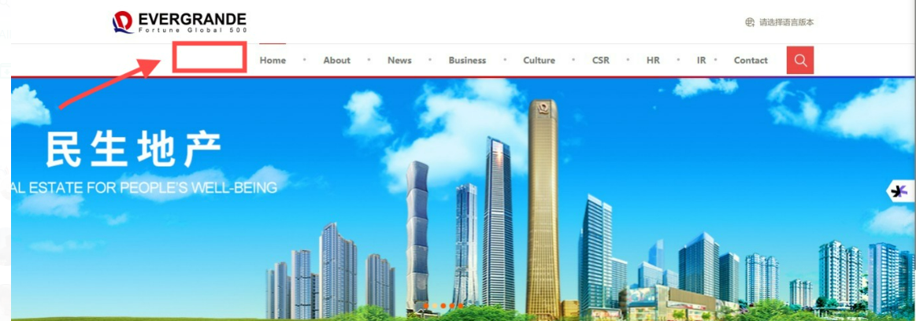 The Evergrande website lacks advanced AI integration, which hampers its ability to provide efficient customer support. Modern real estate platforms often utilize AI-powered chatbots to handle user inquiries, facilitate property searches, and provide instant responses. The absence of such technology results in delayed response times and limited customer support availability. Consequently, users must rely on real estate agents who may not be accessible around the clock, leading to decreased user satisfaction and potential missed opportunities for engagement (Zhang & Li, 2023).

Figure 1.1.1: website homepage lacking options to contact Real Estate AI chat Agents.

Another major shortcoming of the Evergrande website is the lack of personalized user experience. Personalization through AI recommendation systems has become a standard in the digital real estate market, enabling platforms to tailor property suggestions based on user preferences. Without such features, users face the tedious task of manually browsing through extensive property listings. This can significantly reduce user engagement, satisfaction, and conversion rates, which are crucial for competitive digital platforms (Wang, 2022).

The Evergrande website's design as a corporate portal, rather than a user-centric platform, hinders its ability to meet modern customer expectations, affecting both its usability and business outcome.

Ahmed Mirahusain Alvi (TP084807)  
Mohamed Abdifatah Ali (TP082459)  
Abdallah Mohamed Mahmoud Mohamed Mahmoud (TP085097)  
**1.2 Solution**

**Addressing Evergrande’s Issues**

**1.2.1 Lack of Personalization**

Evergrande deals with several issues however one of the most paramount is the lack of Personalization in its services. Evergrande’s customers are usually looking for solutions to some problems which are individual and specific in character. To address this defect, Evergrande can consider taking the following steps:

* **Customized Property Recommendations**: Utilizing the customer data Evergrande possesses, it can make recommendations based on the user's budget, location, and size of property desired; thus, improving the user experience and appreciation of the customers.
* **Personalized Financial Guidance:** Offering tools or consultations such as tailored financial solutions assist customers in appreciating payment schedules that are within their means.
* **Interactive User Profiles**: Facilitating the creation of customer profiles that records their preferences, and past interactions can speed up the sales process and improve its overall usability.

Implementing these personalization solutions would help Evergrande create a stronger connection with customers and meet their expectations effectively. (Greenly, 2023).

**1.2.2 Delayed Response Times and Limited Customer Support**

Delayed responses and limited customer support are significant issues that can deter potential buyers. To overcome these challenges, Evergrande can implement the following improvements: (L. McKim, 2024)

* **Live Chat Integration**: By adding a live chat to its website, Evergrande will be able to respond promptly to any of its customer queries, hence saving them the trouble of waiting and thereby enhancing their satisfaction.
* **24/7 Customer Support System**: With round-the-clock help, both via support teams and chatbots, customers get help when needed, whether it's during the midnight hours of the day in their area.
* **Improved Communication Channels:** The multiple contact means like phone numbers, email, and even social media gave an easy way for the customers to get in touch and always seek support.
* **Customer Support Training**: The staff in the customer service will be properly trained so that they would be able to answer inquiries, resolve issues promptly, and maintain a professional, helpful attitude

**Benchmarked Company (REDFIN)**

Redfin, being the leading real estate company, sets a strong benchmark for Evergrande by offering innovative and customer-centric features that enhance the overall buying experience. In 2004, when it was founded in Seattle, Washington, Redfin was the first real estate company to come up with a technological approach. Real estate brokerage services are offered by Redfin Real Estate company, together with leading-edge tools for making property searches easier to improve customer satisfaction. (Redfin Website, 2024)

Here are several ways in which Redfin excels where Evergrande falls short:

* **Advanced Personalization**

The company uses advanced technology for providing highly personalized property searches and recommendations. It considers user preferences, location data, and past activity while suggesting tailored property listings on the platform.

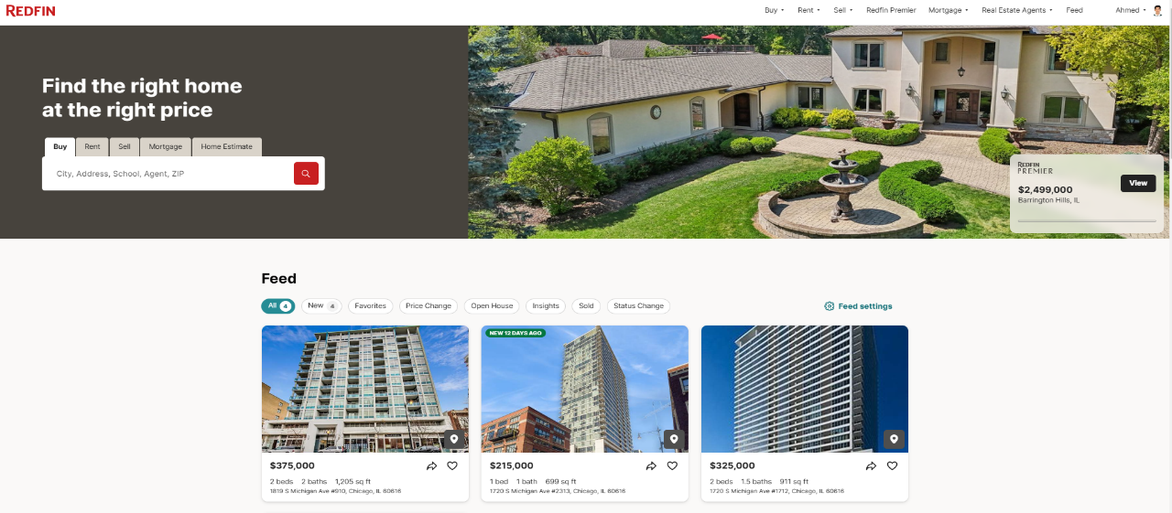

Figure 1.2.1: Redfin website providing personalized feed for its Real Estate buyers

* **Interactive Tools and Resources**

Redfin offers tools and resources like cost calculators, virtual tours, and interactive maps that help customers visualize properties and clearly understand costs. These kinds of interactive tools are currently lacking with Evergrande.

* **Efficient Customer Support**

Redfin has in place a strong customer support system. Fast response rates are enabled over live chat and on phone support, and for localagents who can at times be more efficient in the slow responses from Evergrande.

* **Transparent Pricing**

With Redfin, the clear display of pricing includes agent commission and fees; this reduces buyer confusion, thus building trust and enhancing the buying experience.

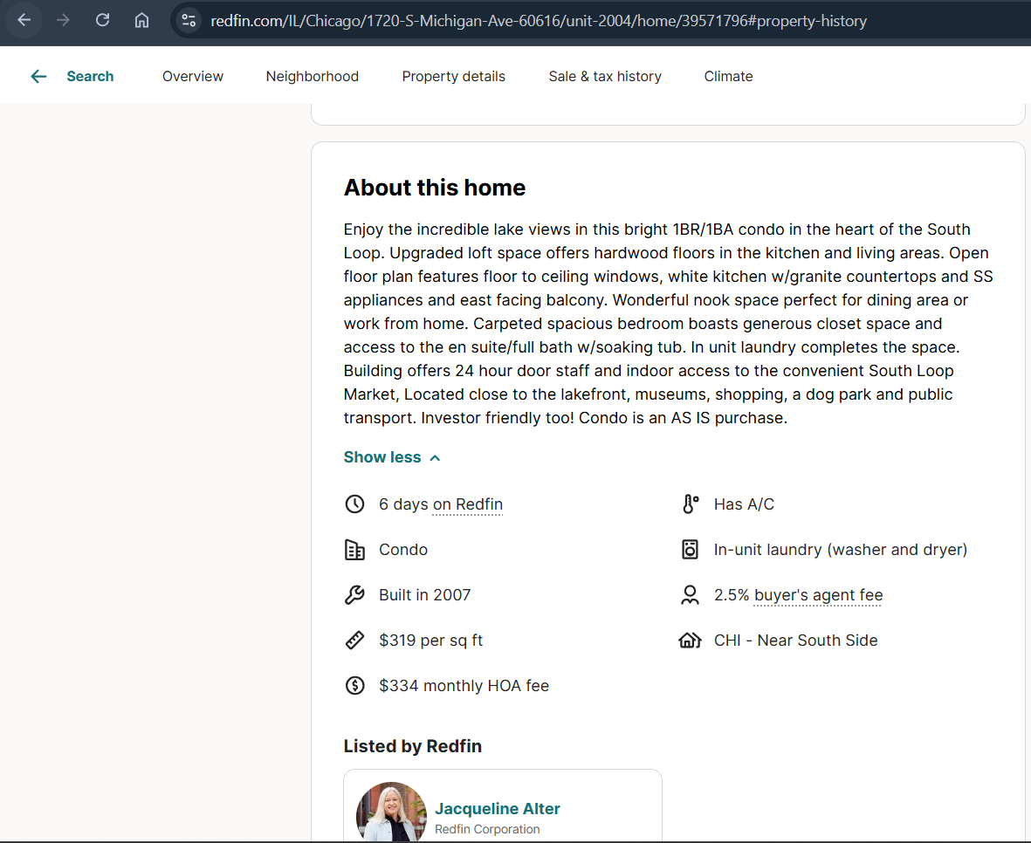Figure 1.2.2: Redfin property webpage with detailed description and pricing

* **Technology-Driven Service**

Technologies like AI-driven property insights and real-time market updates are integrated within Redfin to give customers up-to-date information to make informed decisions.

By learning from the strengths of Redfin and following similar customer-centric strategies, Evergrande could fill in its current gaps, improve customer satisfaction, and stay competitive in the real estate market.

**Derived Concepts**

Implementation of these solutions will help Evergrande improve customer experience, enhance decision-making, and foster long-term customer loyalty. In doing so, Evergrande will differentiate itself from its competitors and establish itself as a progressive real estate company by emulating the successful strategies of industry leaders like Redfin. (Redfin Website, 2024)

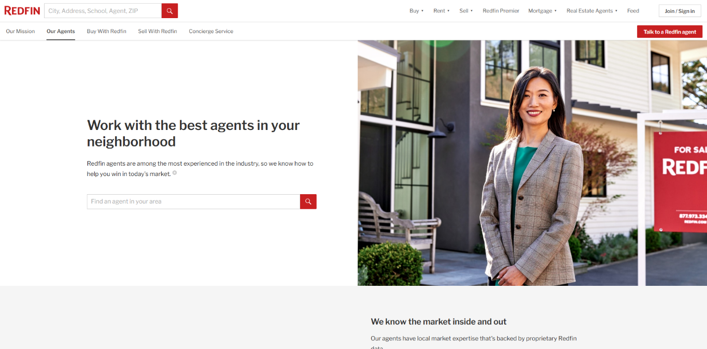  
Figure 1.2.3: Redfin website featuring a search menu for Real Estate agents

A professional real estate agent would greatly improve Evergrande's service, making it more reliable and focused on customers, just like Redfin does. With professional agents, Evergrande could offer personalized guidance, streamline processes, and improve client satisfaction, which would help the reputation and success of the company. (Redfin, 2024)

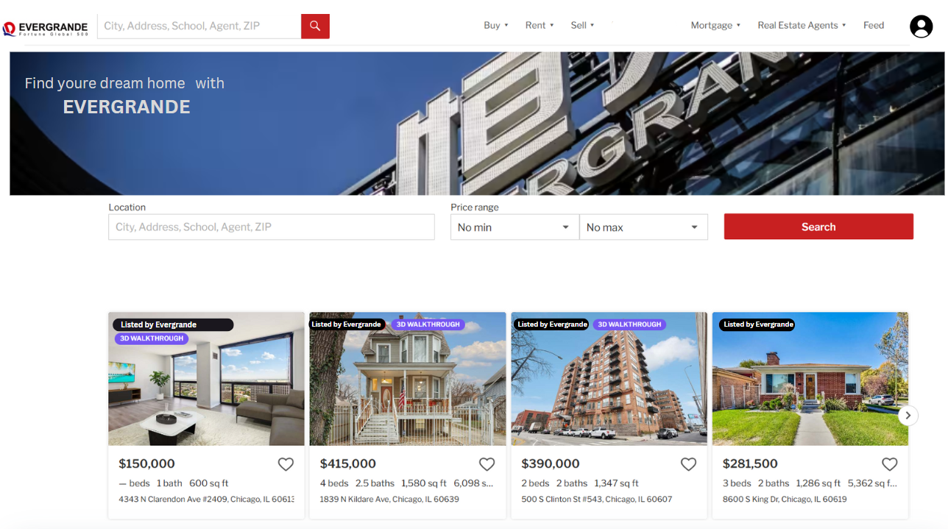**Ahmed Mirahusain Alvi (TP084807)**  
**Mohamed Abdifatah Ali (TP082459)**  
**Abdallah Mohamed Mahmoud Mohamed Mahmoud (TP085097)**  
**1.3 Prototype**

figure 1.3.1: New Evergrande web design for browsing properties

This search page prototype helps users find real estate listings efficiently, according to their personal preferences, by providing a simple and user-oriented interface. The following describes how it works:

* **Streamlined Navigation and Search**

The prominent “location search bar” at the top allows users to enter specific parameters like city, address, school, agent, or ZIP code. This flexibility meets the needs of users who have different goals when searching-either researching neighborhoods or targeting specific addresses. The “price range filter” makes it easier for users to narrow down the results according to their budget, ensuring they view only properties that fit their budget. The "Search" button is very visible and well-placed next to the filters, prompting users to proceed without hassle.

* **Intuitive Layout and Visual Appeal**

The design of the webpage incorporates distinct headings, high-resolution images, and systematically arranged content. Visitors are greeted by a “banner” showcasing the brand name "EVERGRANDE" alongside a polished background, thereby fostering trust. The format for property listings employs a grid layout that utilizes images to accentuate the attractiveness of each property. An initial thumbnail image draws immediate attention and offers a visual glimpse of the residence, enhancing the browsing experience. Key information about each property, such as price, “number of bedrooms and bathrooms, total area, and location”, is clearly displayed under each photo. This setup allows users to quickly evaluate the most important information without needing to open each listing.

* **Interactive Features**

The "3D WALKTHROUGH" tags enhance the user experience by indicating properties that offer virtual tours. This feature is especially useful for buyers who are far away or those who would want to virtually see homes before physical visits. The "Listed by Evergrande" tags instill confidence by associating the properties with a reputable real estate provider. The ability to view “multiple listings at the same time “allows users to compare options by characteristics, price, and location.

* **Efficiency in Deciding**

By displaying various properties on one page, users can sift through listings systematically to identify homes that meet their needs. Every property card is interactive, supposedly leading users to complete property pages with access to more images, features, and agent contact information.

In a nutshell, this prototype of the search page provides a unified and user-friendly process for prospective homebuyers or renters. Intuitive search capabilities, attractive listings, and features that make browsing easy all contribute to saving time for the user to make well-thought-out decisions. Its organized layout ensures ease for users of all technological skills.

**Map features:**

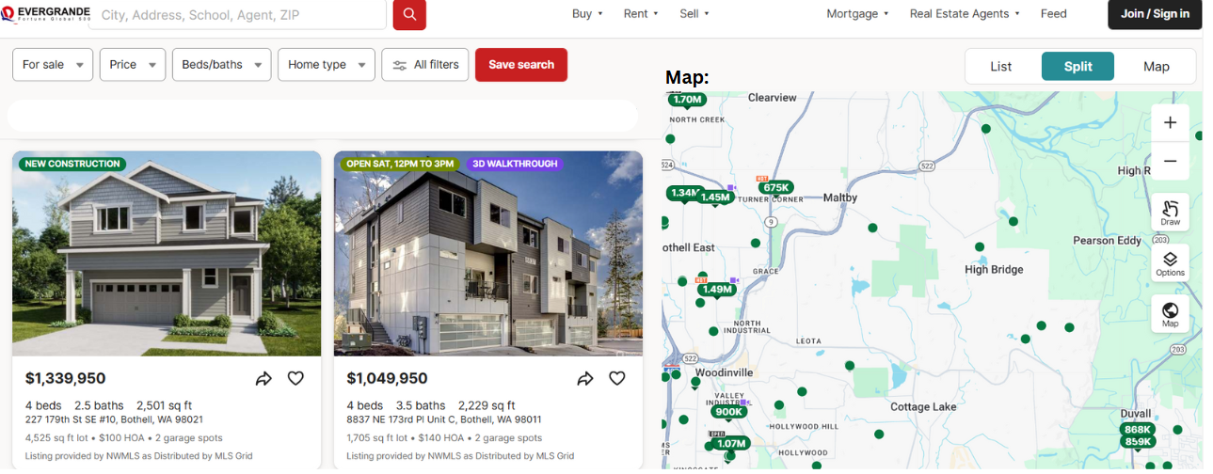 Figure 1.3.2: New prototype showcasing locations of real estate homes on sale

This prototype for a search page is made to help users improve their property search. Property listings are combined with the map, where the user will have an easy yet clear way of browsing their property.

On the left side, an entire property description will include vital information such as price, number of beds and baths, size, and location information. With tags ("NEW CONSTRUCTION" or "OPEN SAT, 12 PM TO 3 PM"), it makes it easier for quick searches to pick out homes of interest. Images also make an easy visualization of the property, as it lets the user make decisions faster.

To the right, the interactive map allows users to look at properties by location. Properties are represented by green dots, and the prices are shown right next to them for easy identification. This allows individuals to determine houses located within the neighbourhoods they want and see price trends based on geographical boundaries. Zooms and pans also ease access to narrowing down a search area by user.

Users can further limit their searches using additional filters, including price, beds/baths, and home type, available on the top. In combination with the option "Save search," users can easily access or keep tabs on their favourite properties.

In summary, this design combines images, searchable tools, and location data for a more effective and friendly house search experience.

CHAPTER 2: OUTDATED DESIGN

Jonathan Lilio Saputra (TP078746)  
Jonathan Christian Lengkong (TP079992)  
**2.1 Issue**

Evergrande’s website at first glance looks fine, but if it's by today's standards it will fall behind. The user will know this because if they click on the link of the website, it will send the user to a “About Us” Page instead of what they have expected. Even if the user clicks to the home page, the user will not find any real estate or property related products. Instead, they will find out about the news. Since Evergrande is a real estate company, many users will probably expect to have a search bar on what or where they want the property that they are interested in on the first page like many other companies. Not only is the design of the website considered old but also hard to navigate, frustrating the user and making it hard for new potential customers to learn how to use the website.

Having an old website also means that it is quite slow. The user may think that their internet is the problem, but it is not. Since the company has just had a big loss due to the Chinese property sector crisis in 2021. Evergrande has filed bankruptcy in the United States in 2023. This could lead to low maintenance on the website making it not optimized. Any user will probably also leave the website in search for a better, faster, more optimized, and easy to navigate website for a better user experience.

Other than design the website also lacks in the features department. Compared to other companies like RE/MAX and Zillow, we can see that Evergrande’s website doesn't even have a buy, rent, or even a choice for the user to create an account. Creating an account is very crucial since it will help the user to save or bookmark the property that they are interested in, helping the user to also save their search history. Evergrande’s website is also not disabled friendly, the website doesn't have a voice to search feature that will help some people in need. To be Specific for the person that cannot use the keyboard.

(Amaranth, 2024)

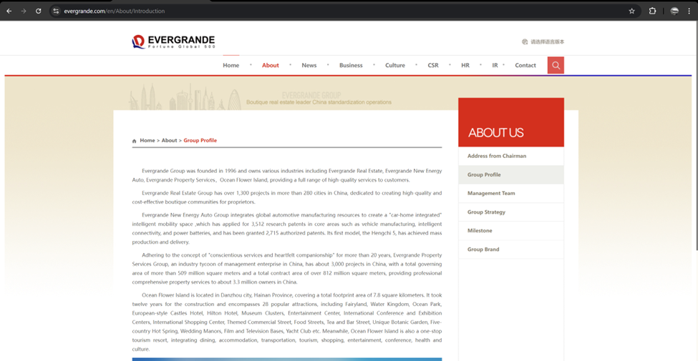Figure 2.1.1: Evergrande’s current website

(Evergrande’s Group, 1996)

Figure 2.1.1 depicts Evergrande’s current website, the websites design is not appealing to a lot of people because the website looks too formal, and it lacks a lot of features.

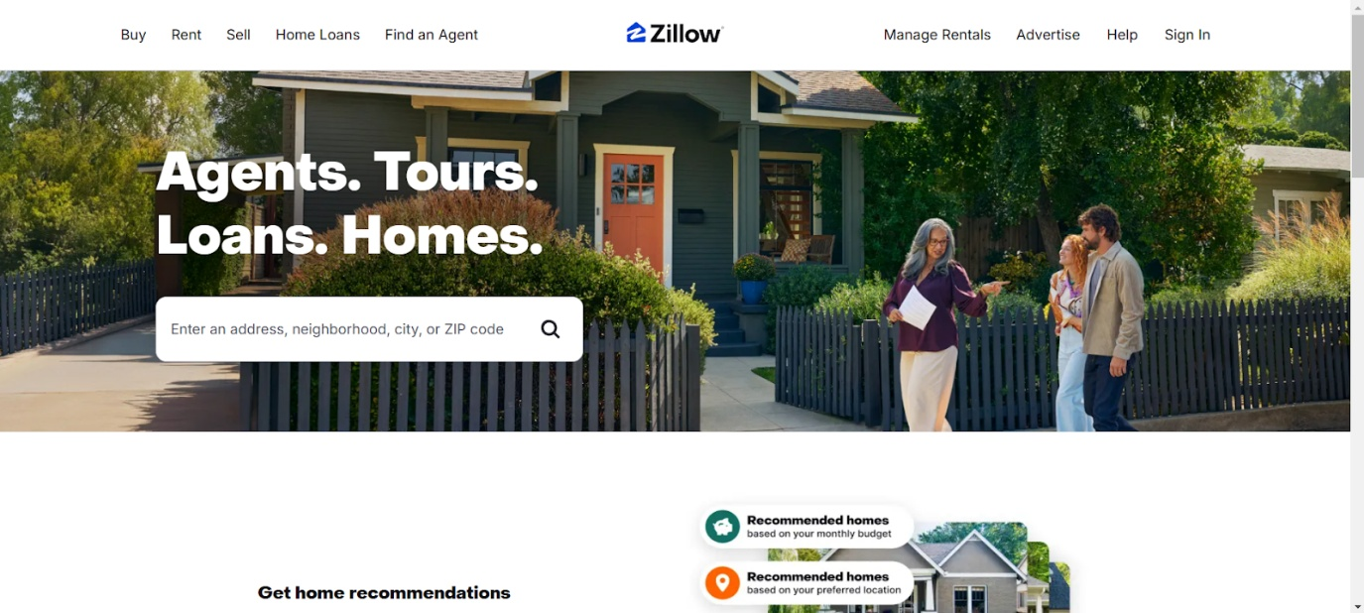

Figure 2.1.2: Zillow’s website

(Zillow Group, Inc., 2006)

Figure 2.1.2 depicts an example of another website where it is visually appealing and it has a lot of features like adding a search bar and a sign in feature, this website has much more colourful design.

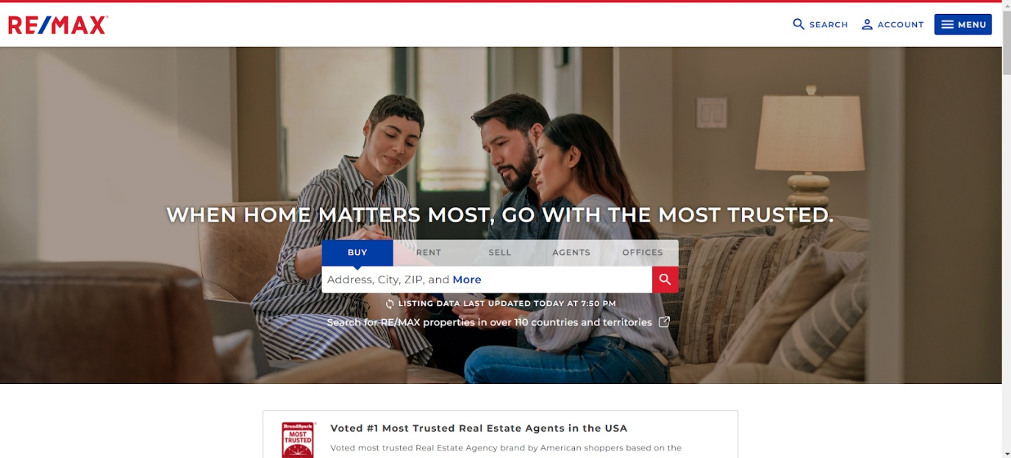

Figure 2.1.3: RE/MAX website

(Real Estate Maximums, 1973)

Figure 2.1.3 depicts another example of a website that is what you call a “modern website”, as you can see this website also has a visually appealing design, it also has a lot of features compared to Evergrande’s website.

Jonathan Lilio Saputra (TP078746)  
Jonathan Christian Lengkong (TP079992)  
**2.2 Solution**

Redesigning the Website:

The only solution to an old website design is to completely redesign it. By redesigning the website this can benefit a lot for the company. Not only for the company but for the customers as well. The company can attract more customers, especially younger customers because they can find the website more appealing and easier to navigate. Since the website is easier to navigate, it will also help with efficiency, making the website faster and giving the user results of what they want more accurately. Evergrande can also attract more potential customers since the website is easy to use and has been recently renewed. Users can recommend other users to use Evergrande’s services instead of others. From the user perspective they are getting services that are way better like faster Website load times, more accurate results, more options that they can choose from, and many more.

Redesigning the website also means that the website will have more features then other. Adding: Meet an Agent, Voice to search, and many more will help in the user experience. The cost of running the website will also decrease since it is re-newer and more efficient.

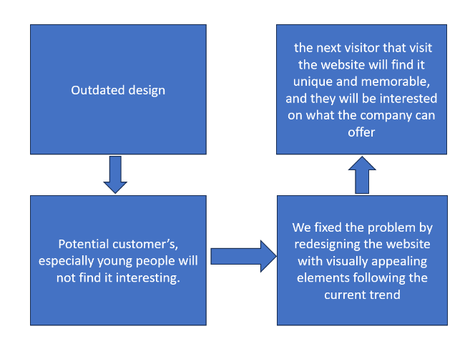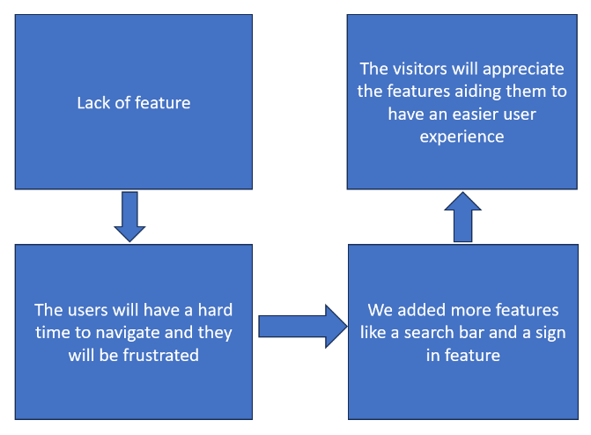

Figure 2.2.1: flowcharts

The two flowcharts above shows the two main problem and what it caused, then we showed the best solutions we can think of and what it can improve.

Jonathan Lilio Saputra (TP078746)  
Jonathan Christian Lengkong (TP079992)  
**2.3 Prototype**

This prototype will change the whole design of the website. Not only this, but we can also see that the prototype has more features like:

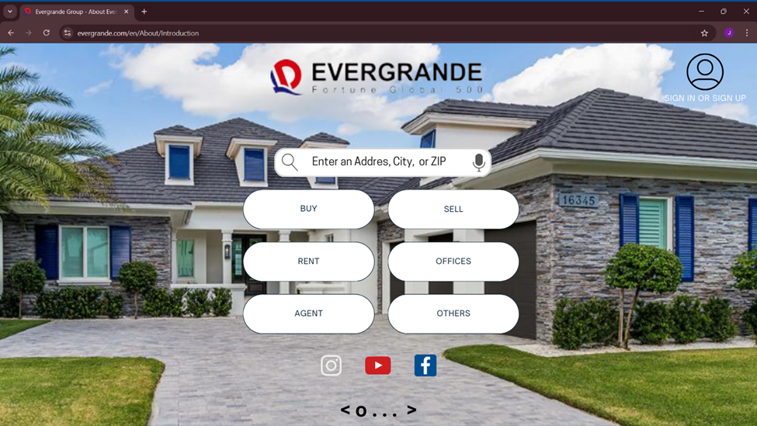Figure 2.3.1: Proposed re-design website

Adding the Search bar in front, we added a Search bar Feature because we noticed that there was not a search bar, a search bar feature is crucial for the users so that they can quickly and easily find what they are looking for without navigating through multiple pages. Because this is a real estate website, users often visit with specific needs searching by address, ZIP code, or city. By making this the first interaction point, the website becomes more intuitive, reducing user frustration and improving the overall experience. Because this is a real estate website, users often visit with specific needs searching by address, ZIP code, or city.

Adding a sign in and a login feature, this feature was added because there isn’t a sign in and log in to save the user’s saved properties in the “Evergrande’s” actual website. This allows users to create and manage accounts, providing a more personalized experience. This feature enables users to save properties they are interested in, eliminating the need to search again. Also, the users that come back will appreciate the convenience of logging back in and finding their saved preferences, fostering user loyalty and repeat visits. It also opens opportunities for Evergrande to gather user insights and offer tailored recommendations.

Social media links at the bottom, social media integration increases brand connectivity and trust. The Users can quickly explore the company’s social presence, gaining insight into its offerings, reviews, and updates. Linking to platforms like Instagram or Facebook also allows Evergrande to showcase visually engaging content, such as photos of new properties, customer testimonials, or virtual tours. This feature can attract a lot more people, an audience that relies heavily on social media for decision making.

Meet an agent, this feature was added to attract customers that wants to see before they purchase, it also helps gain trust in the business, this feature serves a critical need for customers to schedule physical tours or consultations with real estate agents. Buying property is often a hands-on decision, requiring trust and a personal connection with an agent. By streamlining the process of meeting agents through the website, the company reduces friction for potential buyers. This also highlights Evergrande’s commitment to customer service and convenience, setting it apart from competitors without this functionality.

Putting some properties photos in the front, we decided to put pictures of some properties on the homepage like some high-quality photos of properties are essential for grabbing visitor’s attention and keeping them engaged. Visual appeal is a powerful tool in the real estate industry, as customers often make their first impression of a property through pictures. Showcasing properties prominently demonstrates the company’s offerings and creates a sense of professionalism and transparency. It can also help guide users toward exploring specific listings or property categories, driving engagement and sales.

Search by voice function, we decided to add this feature to help the people that are incapable of typing or the ones that have trouble typing, so adding this feature allows users to speak their queries instead of typing, enhancing accessibility and convenience, especially for mobile users or those who prefer hands-free interactions.

**CHAPTER 3: LIMITED SEARCH FUNCTIONALITY**

Andrew Wijaya (TP079319)  
Lim Quan Tai (TP080629)  
**3.1 Issue**

Limited search features and failure to provide accurate property information would be one of the worst fatal to the process of searching for properties. Potential buyers or renters end up wasting a lot of their time, more so on the search and browsing through pages that had misleading information. Properties that are stated as ready to be rent or sold, for example, may have already been purchased or leased, which may be a source of annoyance since one would have been looking forward to acquiring the property. Also, certain properties may be priced reasonably or located in good areas but do not show up on search results because there is either incomplete or incorrect information about these properties.  
   
 Ineffective search algorithms only worsen such a situation. Mostly the algorithms that have not been configured rightly to filter the results tend to pull up irrelevant and incomplete features listing, which makes it difficult for the users who are searching for property that corresponds with any of their features. The searches however are not in any way or form the users have prescribed, searching for not only the location but also price and type of property, can only but cause disappointment and unfriendly disorganization in the search process.  
   
 When considering renting out properties or buying them, the amalgamation of the above issues may cause confusion. They might lose out on better opportunities or spend time looking for properties that may not even be in existence. Such unproductive processes do not only lower the confidence of users of the property searching platforms. The motto of real estate customer *is accurate up to the last detail, relevant result and cheap*. Taking such a challenge that is necessary to boost the accuracy of data provided and fulfilling the people satisfactory.

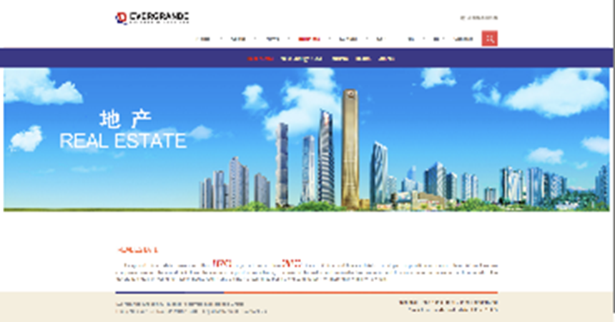

Figure 3.1.1: The Evergrande website

Figure 3.1,1 shows that the menu option for is only have the Evergrande company name and it still lost its function which as a place to search the property. In here, the company did not add any search bar and all the options to choose the property.

Andrew Wijaya (TP079319)  
Lim Quan Tai (TP080629)  
**3.2 Solution**

Make a more compact search function in the main menu with more features

* **Custom Filters for Targeted Searches**

Custom filters at the discretion of users' location, price range, property type, amenities can all be chosen in conformance with what exactly has been specified by a user according to his taste and preference. A customization of this kind is necessary because one would thus be able to target a property that meets their requirements and would save time, excluding properties beyond one's interest. Be it filtering by state, city, or even a particular neighbourhood, custom filters help users filter out options and find the most suitable properties in no time.

Such filters enhance user experience by giving full control and flexibility during a search. A very fair and affordable price range that one may pay or can simply exclude all such properties, which cannot entertain the minimum number of bedroom requirements or distance from public transports. This, apart from returning more apt results, further ensures giving better opportunities to users who hence will make better decisions on this ground. Property Websites that Provide Highly Custom Searches enhance customer satisfaction and more involvement in it.

* **Sorting Properties by Date of Listing**

Sorting properties by listing date will be especially useful for the user who needs the most updated options. In such a way, by establishing the properties with the latest listings at the top, users can easily view the newest properties available on the market. This will keep the buyer or renter updated with recent additions so that they will not miss newly listed opportunities that may fit their criteria.

Besides, the ability to sort by listing date will rid many of the confusions that dead listings have caused, such as finding a property already sold or rented. It cleans up listings for new ones, reducing the rate at which users find unrelated results. This feature will keep the searching process not only attuned to the times and swift but will also build trust from users in its timeliness and veracity regarding property data.

* **Addressing Outdated Listings and Unfiltered Results**

Updates to obsolete listings ensure relevance and reliability on the property search site. When properties that are already sold, let, or otherwise no longer available start showing up on the search platform, that is where the frustration of users and the loss of faith in the service begin. Regular updating of the property database keeps the database fresh with active properties for user choice; this includes removing inactive listings. This enhances the user experience and increases the reputation of the platform as a source where house hunting can be reliably done.

Additionally, unfiltered results hurt much when the number of properties given is many and there is no match to the users' expectations. It allows the end clients to do some custom filtering of the price range, location, and property type for short-listing properties toward their preference only. This saves time; hence, decision fatigue is reduced, which enhances the overall efficiency of the search, therefore leading to higher satisfaction of the users.

**Benchmarked Company (IPROPERTY)**

The nature of the IProperty platforms is so friendly that it makes the hunt for properties quite easy. As a buyer or renter, it is simple to get through these platforms properties that precisely match their needs. With custom filters, advanced search options, and interactive maps, one can narrow down faster to specific criteria like price, location, size, or amenities. How much this convenience tends to save time for users while making a better decision could not be underestimated. The fact that photos and property descriptions, complete with virtual tours, were included really added to the experience and clarified many things on the property much prior to visiting them.

Some of the other major advantages the online portals of IProperty bring to their customers, among clients, can access properties at anytime, anywhere whether through a cell phone or on the website. This is helpful in cases when busy with schedules or when one may wish to move to any other place. Most keep updating the listing list and give real-time notifications so that no new deal may get missed. Quite a suitable number of services have built-in facilities in the form of mortgage calculators, neighbourhood guides, and agents' accessibility at fingertips thus making property search easier but much more thorough and quicker.

**DERIVED CONCEPT**

After me and my teammate researched the website, we found that the search function is good. One of the features that I like is a custom search function. This can let customer to search the type of property that they want. Not only that, but they can also list by the time they post it. This can let customer know if the house has a lot of interest or not by the public. Lastly, they can address the listing the outdated listings and unfiltered results. this can make sure that the property that have not attention can be throw out, which can reduce the time the customer to search.

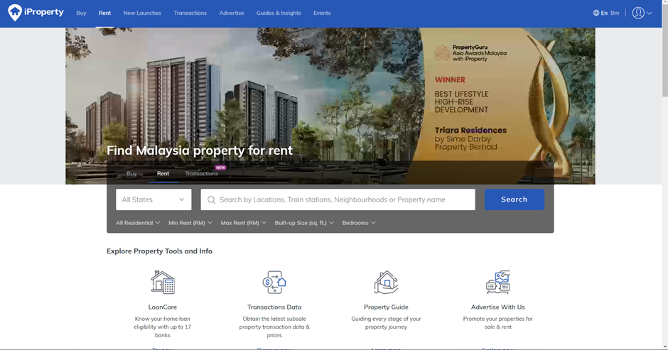Figure 3.2.1: The IProperty website

The Figure 3.2.1 show that IProperty website have a significant difference between the Evergrande website and I Property website. The I property website has much more search function and it has more option to choose rather than the Evergrande one.

Andrew Wijaya (TP079319)  
Lim Quan Tai (TP080629)  
**3.3 Prototype**

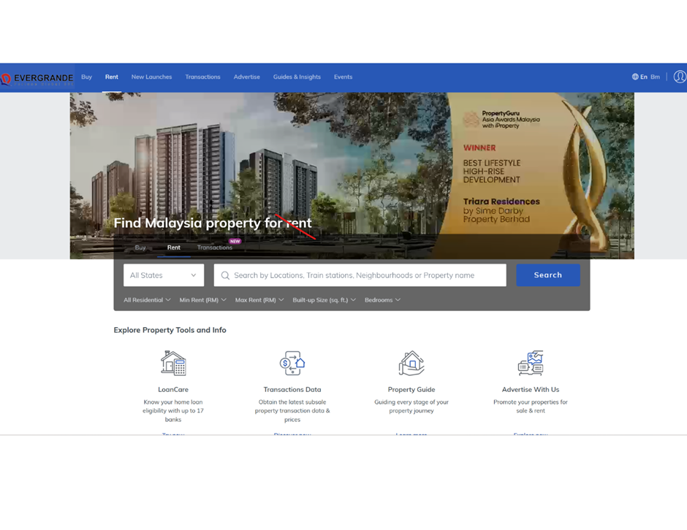Figure 3.3.1: the Prototype of Evergrande website

Figure 3.3.1 shows the prototype of Evergrande website that it can improved such as well-planned main page, helps the users to pinpoint precisely, the area and location they are interested in. Users can estimate a rough area that fits their desires, by having a visual map or region-based navigation concept.

Furthermore, intelligent algorithms can decrease the time of searching considerably. Advanced algorithms can be used to optimize the layout, considering such user preferences, as proposed budget, desired property area and its amenities and so on. Thanks to these algorithms, users will be shown only the properties that fit their criteria, thus improving their satisfaction. A best layout of an effective homepage plus intelligent algorithms makes a property search system all in one smooth and effective experience.

**CHAPTER 4:**  
 **ABSENCE OF A MORTGAGE CALCULATOR**

Hansen Nicholas Can (TP075390)  
Archie Nicholaus Yiedri (TP081430)  
**4.1 Issue**

Evergrande’s website lacks a feature that is common for a real estate company’s website, a mortgage calculator. A mortgage or home loan calculator is a digital tool that estimates your monthly payment and the terms of your mortgage(Chase). A mortgage calculator usually presents information such as the monthly mortgage payments, including a breakdown of the principal and interest, property tax, insurance, the length of mortgage in years, fixed or adjustable interest rate, and the Annual Percentage Rate (APR). This information helps the buyer to make an informed decision when contemplating buying a property.

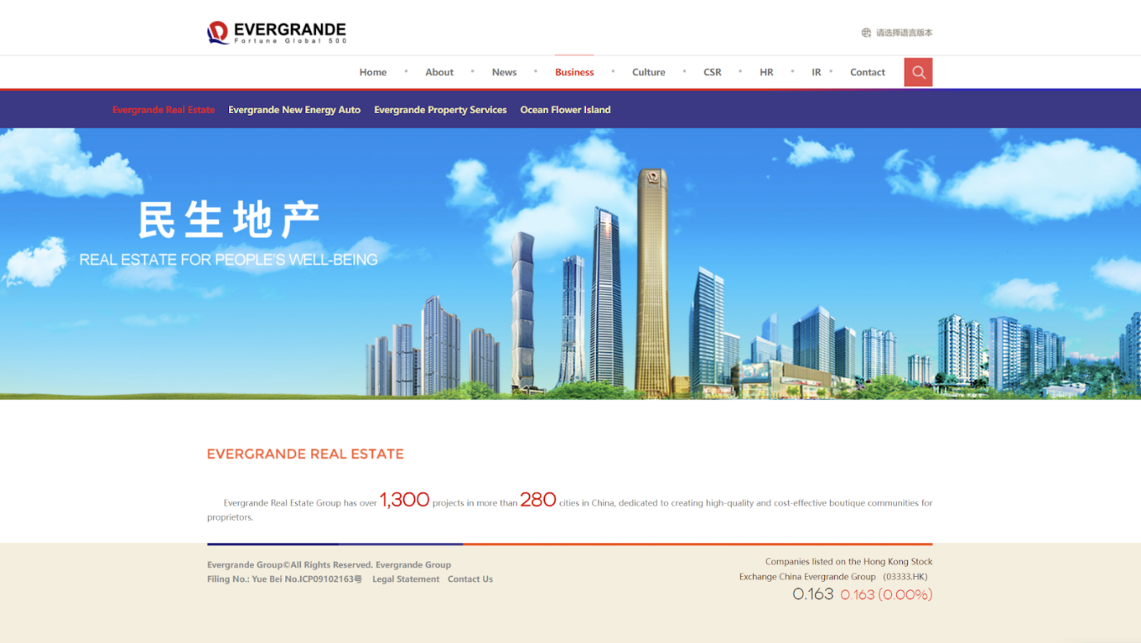

Figure 4.1.1: Evergrande’s website

While such a feature is not essential to have for a company’s website, it is quite important for a real estate company’s website to have it. The absence of such a feature would result in a few disadvantages / negative outcomes. Without a mortgage calculator buyers might not understand the true cost of their property, leading to unrealistic expectations, which would cause potential buyers to not move forward with their purchases. Due to the unclear pricing, clients would lose faith in the company, resulting in them deciding to cancel their purchase, impacting on the cash flow of the company.  Figure 2.1.1 shows how Evergrande’s website does not have a button or a function for a mortgage calculator.

A mortgage calculator is a feature that can generally be found on every real estate company’s website. By lacking this feature Evergrande’s website would lower its competitiveness compared to its competitors’ website.  The absence of a mortgage calculator might signal to potential clients that transparency is not one of the company’s strong suits. By being transparent the company can build trust with the customers. In a world where a customer can easily choose a competitor just with a click of a button, having a foundation of trust is crucial. A transparent brand distinguishes themselves from other brands by being known as a trustworthy and authentic brand, which resonates deeply with customers (Greenly, 2023). The company might struggle to attract potential buyers due to lack of transparency, leading to project delays and financial issues, contributing to the financial crisis Evergrande is currently facing.

Hansen Nicholas Can (TP075390)  
Archie Nicholaus Yiedri (TP081430)  
**4.2 Solution**

**Design and implement a mortgage calculator:**

Designing and implementing a mortgage calculator on the website of Evergrande would solve customer concerns and provide Evergrande with an advantage. This feature would enhance transparency, accelerate the buying process, and increase buyer confidence for several reasons, such as

* **Gaining User Trust**

The calculator would allow users to see the true cost of their property without any hidden fees while providing the cost in a complete yet easy-to-understand format, this would build up trust among customers, which would significantly help Evergrande as gaining trust and retaining customers is one of the most important factors to a successful real estate company (Greenly, 2023)

* **Speeds Up Decisions**

Simplifying complex financial data would reduce confusion for the customer, and by presenting a simplified result, this could help the customer make their financial decision in a shorter time span, leading to a faster and smoother transaction.

* **Enhance Competitiveness**

Like several competitors such as Sunway properties, a mortgage calculator would modernize Evergrande’s website, which would attract potential buyers. This would put Evergrande in a position as an innovative and customer-based company

**Benchmarked Company (SUNWAY PROPERTIES)**

Sunway Property is one of Malaysia’s major real estate companies, with projects in 4 countries: Malaysia, Singapore, China, and the United Kingdom. Sunway Properties have built over 34 thousand Residential, Commercial, and Retail Properties and developed an estimated value of RM 52.9 billion across 2,467-acre landbank. Established in 1974, Sunway Properties have developed properties in 4 regions in Malaysia: Klang Valley, Johor, Ipoh, and Penang (Sunway Corporate Website, 2024).

**Derived Concept:**

The mortgage calculator is a simple feature, yet it has been proven to be effective in the real estate industry, such as Sunway property, which is one of Malaysia's largest real estate companies. Sunway property’s mortgage calculator provides a simple to use design for users and produces detailed yet easy to understand results. By simplifying the financial information, this has allowed users to visualize the costs clearly, allowing them to make more informed decisions when purchasing (Sunway Corporate Website, 2024)

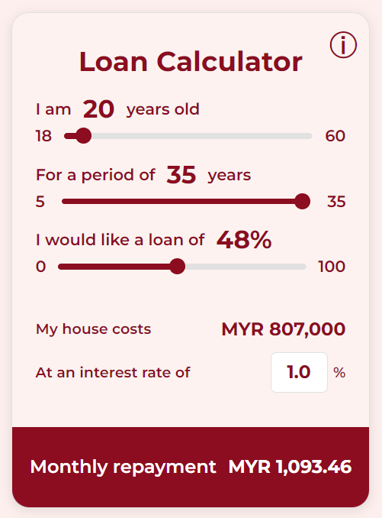

Figure 4.2.1: Sunway Properties mortgage calculator

A mortgage calculator would help Evergrande become a transparent and customer-centric brand. By addressing buyer concerns and improving decision-making, it increases customer trust, sales conversions, and growth (Greenly, 2023).

**Objective Flowchart**

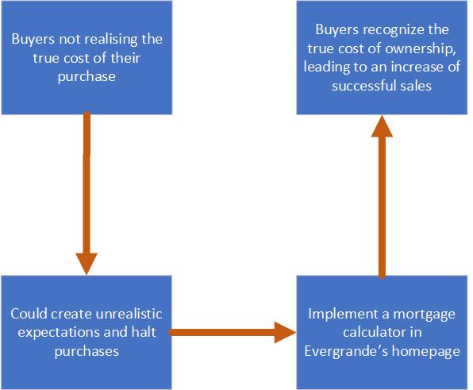

Figure 4.2.2: True Cost Flowchart

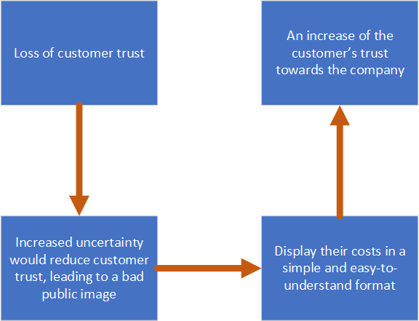

Figure 4.2.3: Customer Trust Flowchart

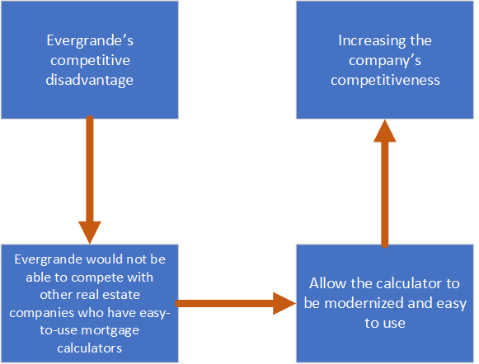

Figure 4.2.4: Competitive Disadvantage Flowchart

Figure 4.2.2 - 4.2.4 demonstrates several key problems that Evergrande faces with the lack of a mortgage calculator, including loss of customer trust and decreased competitiveness. The flowchart describes a summary of the negative impacts that the problem would cause, along with a possible solution for each problem and how they would positively affect Evergrande’s overall brand.

Hansen Nicholas Can (TP075390)  
Archie Nicholaus Yiedri (TP081430)  
**4.3 Prototype**

The proposed prototype will be integrated seamlessly into Evergrande’s Homepage, positioned conveniently to ensure easy access for users. Upon selecting the calculator feature, users would be directed to an initiative interface designed for simplicity and effectiveness.

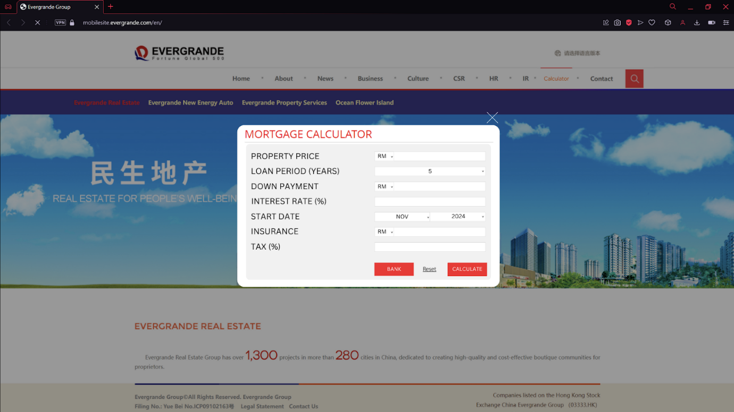

Figure 4.3.1 A prototype design for a mortgage calculator in Evergrande’s Homepage

The calculator would offer multiple input fields for the user’s essential data, such as:

* Property Price: the cost of the selected property.
* Loan Period: the desired duration of the mortgage.
* Down Payment: initial amount paid upfront.
* Interest Rate: the applied interest rate, fixed or adjustable, depending on the selected property.
* Start Date: when the user intends to start their payments.
* Insurance and Tax: additional costs associated with the property.

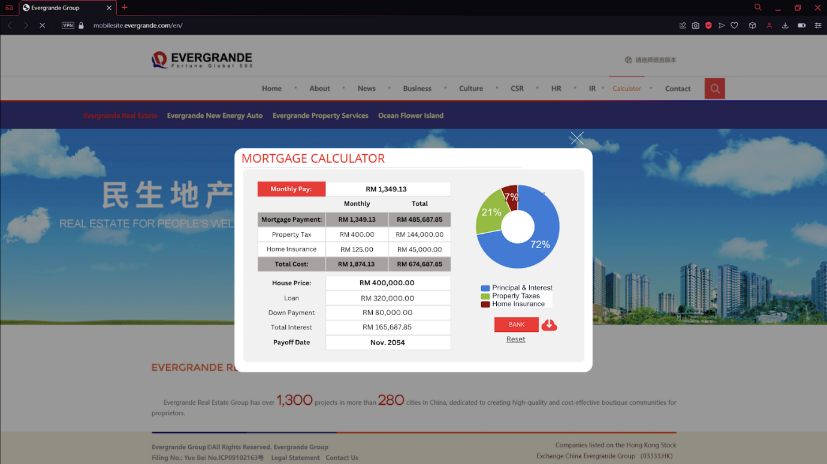

Figure 4.3.2 Example of the result of a calculation from the mortgage calculator

Upon entering these details, users will instantly see a visualized result of their calculation, such as their monthly payment, total amount owed over the years, and a simple breakdown of other costs and their impact on the final price. These results will be presented numerically and through a pie chart, providing a visual representation of cost distribution (Mortgage Calculator, n.d.). This functionality ensures that users can easily comprehend the financial implications of their purchase.

Along with displaying the final calculations, the calculator would also provide advanced features such as a Bank interface, where users will be able to contact their banks directly, improving loan applications and allowing users to discuss financing options (Chase, 2024). Another feature is the Save button, allowing the users to share their calculations, improving collaboration between buyers and other potential clients, and improving transparent communication (McKim, 2024).

This prototype will bring several advantages to both Evergrande and its users. Buyers will have a detailed understanding of their financial decision, improving their trust and confidence in the company's offerings, giving Evergrande the appearance of an authentic and reliable company (Greenly, 2023). This clarity will improve decision-making, accelerating the purchasing process. Additionally, the transparency provided by the mortgage calculator will allow Evergrande to appear as a customer-focused brand, distinguishing it from competitors.

This tool will not only increase user engagement but also enhance Evergrande’s reputation for financial transparency. By attracting and retaining buyers, the calculator can contribute to higher sales conversions and sustained growth, ensuring Evergrande remains competitive in the real estate market (Greenly, 2023).

CHAPTER 5: LACK OF VISUALIZATION FEATURES

Mohammed Yousef Mohammed Mohammed (TP085042)  
Mahrus Shamsul Ahsan (TP085562)  
**5.1 Issue**

**No virtual 3D tours:**

The process of using specialised software to create digital, three-dimensional representations of properties is known as real estate 3D modelling. These models, which provide previously unheard-of detail and interaction, can display both existing properties and those that are still in the planning stages. Without 3D models, investors missed the chance to see a detailed view of the buildings. This limited their ability to fully visualize the structures. Potential buyers may find it difficult to visualize properties, leading to decreased engagement and interest. This limitation can result in reduced inquiries (Easy Render. (n.d.))

However, the lack of immersive visual tools can hamper decision making and delay transactions, reducing the efficiency of the real estate market.

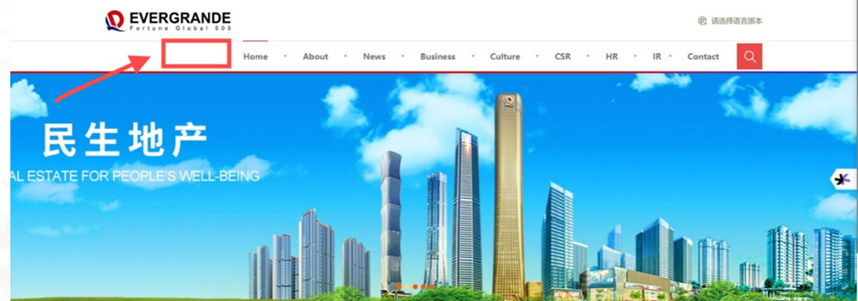

Figure 5.1.1: Website homepage with no Virtual Tour option

The lack of a 3D tour on the website, as seen in the above image, has an impact on the business since it prevents the buyer from seeing the entire house he plans to purchase and prevents the company from showcasing new projects to gather feedback before construction starts. (Smith, J. (2022))

Mohammed Yousef Mohammed Mohammed (TP085042)  
Mahrus Shamsul Ahsan (TP085562)  
**5.2 Solution**

**Provide 3D reference map:**

As 3D reference map improves customer understanding and decision making, they have completely changed the real estate industry. These visual aids provide customers with a clear layout and spatial awareness, making it easier for them to understand the overall arrangement of a home or space. Customers choose the property that best suits their individual tastes. (Mellionard, M. (2023, April 17))

Planning renovations or installing furniture is made easier thanks to this feature that removes any doubts. Additionally, by eliminating the need for in-person visits, 3D Reference Maps allow customers to view and evaluate properties remotely, saving them a significant amount of time. (Mellionard, M. (2023, April 17))

These interactive visualizations help consumers make informed decisions more quickly, enhancing the buying experience and simplifying the selling process for real estate agents. By providing more convenience and interaction to buyers, this technology has emerged as a vital tool in contemporary real estate marketing. (Mellionard, M. (2023, April 17))

**Benchmarked Company: Matterport**

Matterport, a leader in spatial data, provides cutting-edge solutions for creating and exploring 3D spaces. Founded in 2011, Matterport has revolutionized the way real estate is displayed by providing interactive and immersive 3D models for real estate and other industries. By leveraging the latest technology, Matterport has set the standard for real estate marketing and real estate visualization. *(Matterport. (2023))*

* **Advanced Visualization Tools**

Matterport's advanced visualization tools enable the creation of 3D models of real estate. These tools allow potential buyers and tenants to virtually walk-through spaces, getting a clear understanding of layouts, dimensions, and aesthetics without the need for an in-person visit. *(Matterport. (2023))*

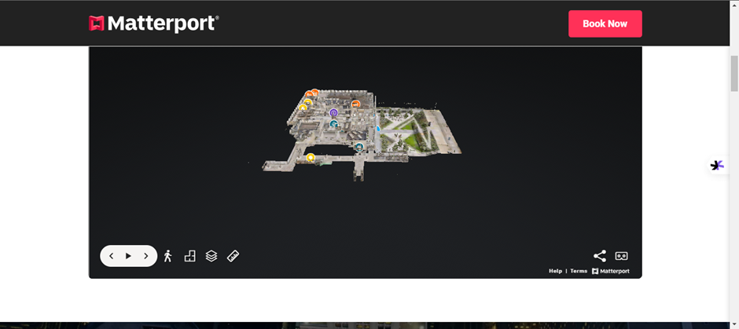

Figure 5.2.1: Matterport company

* **Ease of Use and Accessibility**

Matterport’s platform is easy to use and accessible, allowing anyone from agents to engineers to create and share 3D models. Its cloud-based system ensures these forms are available anytime, anywhere, allowing for expanded access to 24/7 access to property tours. (*Matterport. (2023))*

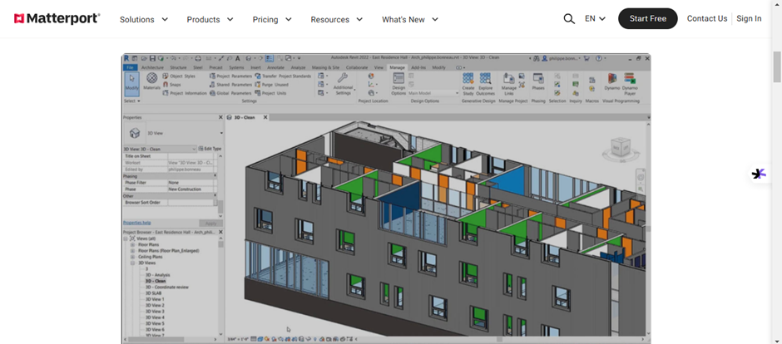

Figure 5.2.2: Accessible website

* **Innovation in Real Estate Technology**

Matterport’s use of artificial intelligence and machine learning enhances the accuracy and quality of its 3D models. With features like automated measurements and real-time collaboration (*Matterport. (2023))*

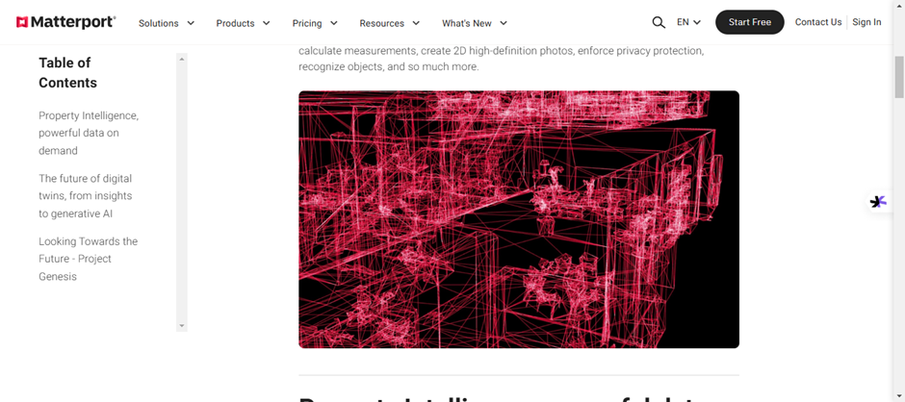

Figure 5.2.3: Utilizing AI

By utilizing similar technologies and strategies, companies can improve their customer experience, streamline operations, and remain competitive in the modern real estate landscape.

**Derived Concepts**

Implementation of Matterport’s innovative features would enable real estate companies to:

1. **Enhance Property Visualization**

Providing immersive, high-quality 3D tours helps customers make informed decisions and improves their overall experience.

1. **Expand Market Reach**

Offering virtual property tours ensures accessibility for international and remote clients, reducing geographical barriers.

1. **Streamline Operations**

Automation tools like real-time measurements and integrated marketing solutions save time and resources while boosting efficiency.

1. **Build Customer Trust**

Advanced visualization and transparent property details foster trust and encourage customer engagement.

By integrating Matterport's technologies and learning from its customer-centric approach, real estate companies can establish themselves as innovative leaders in the industry, ensuring long-term success and customer loyalty. (*Matterport. (2023))*

Mohammed Yousef Mohammed Mohammed (TP085042)  
Mahrus Shamsul Ahsan (TP085562)  
**5.3.1 Prototype**

Virtual tours offer perks to real estate companies by improving the property viewing experience and making the process more efficient. Allows potential clients to remotely view properties before purchasing, replicating the feel of an in-person visit. This saves both time and costs for clients and agents by reducing the need for multiple visits to the property. (DesignBlendz, 2024)

Virtual tours also help companies have a wider reach to international clients. these tours are available 24/7, enabling clients to view the property at any given moment without having to wait for agents to give them the tour. Overall, virtual tours streamline the buying and viewing process and improves accessibility and makes property listings more effective. (CloudPano, 2024)

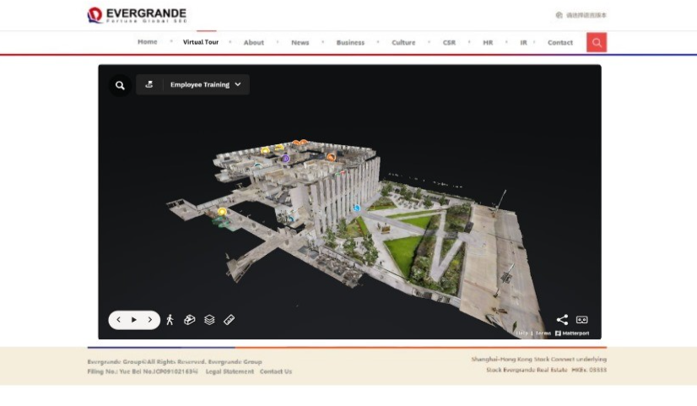

Figure 5.3.1: new EVERGRANDE website

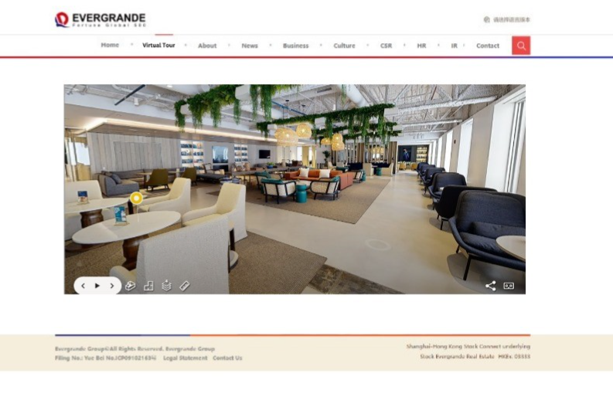

Figure 5.3.2: new EVERGRANDE website

In figure 5.1 - 5.2, a new menu option was added called virtual tour where clients can choose that option to virtually view properties instead of physical visits. Unlike conventional 2d images or videos, this feature provides a 360-degree view of the internal structure, enabling users to explore through the property as if they were physically present. clients can zoom in, rotate, and interact with different elements to get an understanding of the layout, design, and overall feel of the property.

5.3.2 **Website with Street View**:

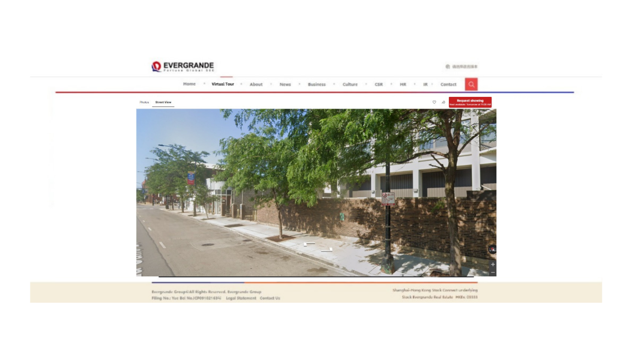

Figure 5.3.3 shows the Evergrande website with 3D Street View

**3D Street View** offers clients the ability to view surrounding environment of the property. This helps clients assess the neighbourhood, nearby facilities, transportation options, and overall location view. It gives a realistic sense of what living in the area might feel like, which is a crucial factor in buying a property.

**CONCLUSION**

The Evergrande Real Estate website faced several critical issues, including limited search functionality, the absence of essential features like a mortgage calculator, and an outdated user interface that diminished usability and brand appeal. To address these challenges, a comprehensive solution was proposed, focusing on enhanced search filters, improved property visuals, a user-friendly homepage, and features such as a mortgage calculator, contact agent options, and virtual tours.

The prototype demonstrated the effectiveness of these solutions by enabling efficient property searches, improving navigation, and increasing transparency, which built buyer confidence. The proposed changes are expected to enhance user engagement, streamline the decision-making process, and improve overall satisfaction with the platform.

Future steps include hiring additional web designers and programmers to elevate design and functionality, as well as involving legal experts to build customer trust. Long-term improvements could involve refining menu accuracy, enhancing services to connect buyers and sellers, and boosting customer satisfaction through superior design and support.

Ultimately, these efforts will position Evergrande for future success by creating a strong first impression, attracting more customers, and fostering growth through improved customer experiences and positive word-of-mouth marketing.

**REFERENCES**

Admin, & Admin. (2024, January 17). Successful Real Estate website features list [2024 Guide] | AMgrade. — Software Development Company -. Retrieved from [https://amgrade.com/successful-real-estate-website-features-list-guide/](https://www.google.com/url?sa=E&source=gmail&q=https://amgrade.com/successful-real-estate-website-features-list-guide/)

Amaranth, H. (2024, December 17). Evergrande Group. Retrieved from Wikipedia: <https://en.wikipedia.org/wiki/Evergrande_Group>

Aqara. (2016). Aqara – Smart Home Solutions. Retrieved from <https://www.aqara.com/en/product/Dynadot>.

Chase, J. M. (2024, January 8). How to use a mortgage calculator. Retrieved from Chase: <https://www.chase.com/personal/mortgage/education/financing-a-home/how-to-use-mortgage-calculator>

CloudPano. (n.d.). CloudPano virtual tour software. Retrieved December 19, 2024, from <https://www.cloudpano.com/>

Colibri Real Estate School. (2024). 21 Tips to Build & Drive More Traffic to Your Real Estate Website. Retrieved from <https://www.colibrirealestate.com/career-hub/blog/tips-to-build-and-drive-more-traffic-to-your-real-estate-website>

Davimes, M., & Davimes, M. (2022, November 30). 10 data sources to inform your real estate strategy. Retrieved from RealTrends Verified: <https://www.realtrends.com/articles/10-data-sources-to-inform-your-real-estate-strategy>

Designblendz. (n.d.). Virtual house tours and architectural visualization services. Retrieved December 19, 2024, from <https://www.designblendz.com/>

Does transparency benefit or harm your company? (2023, October 23). Retrieved from Leaf by Greenly:

<https://greenly.earth/en-us/blog/company-guide/does-transparency-benefit-or-harm-your-company>

Easy Render. (n.d.). Real estate marketing: Benefits of 3D rendering., from <https://www.easyrender.com/a/real-estate-marketing-benefits-of-3d-rendering>

Evergrande About. (1996). Retrieved from Evergrande Fortune Global 500: <https://www.evergrande.com/en/About/Introduction>

Gad, K. C. A. (2022, March 11). The Importance of Accurate MLS Information. Silver City Realtors. Retrieved from <https://www.silvercityrealtors.org/post/the-importance-of-accurate-mls-information>

Grover, B. (2024, October 7). The Complete Guide to Real Estate SEO. HubSpot. Retrieved from <https://blog.hubspot.com/marketing/real-estate-seo>

Greenly, Team. (2023, October 23). Does transparency benefit or harm your company? Retrieved from Leaf by Greenly: <https://greenly.earth/en-us/blog/company-guide/does-transparency-benefit-or-harm-your-company>

Hangzhou Xingzhi Yunqi Technology Co., Ltd. (2013). i-LifeSmart: IoT Solutions. Retrieved from <https://iot.ilifesmart.com/control-center/>

IProperty Group, Inc. (2007). IProperty. Retrieved from <https://www.iproperty.com.my/>

Leaf by Greenly. (2023, October 23). Does transparency benefit or harm your company? Retrieved from <https://greenly.earth/en-us/blog/company-guide/does-transparency-benefit-or-harm-your-company>

Matterport. (n.d.). Cortex AI. From [https://www.matterport.com/cortex-ai](https://www.google.com/url?sa=E&source=gmail&q=https://www.matterport.com/cortex-ai)

Matterport. (2023). Capture services., from <https://matterport.com/capture-services>

Matterport. (2023). Investor relations., from <https://investors.matterport.com/>

McKim, L. (2024, October 16). 21 Tips to Build & Drive More Traffic to Your Real Estate Website. Retrieved from Colibri Real Estate School: <https://www.colibrirealestate.com/career-hub/blog/tips-to-build-and-drive-more-traffic-to-your-real-estate-website/>

Mellionard, M. (2023, April 17). 3D rendering for marketing real estate: What it is and how it can improve your real estate business. Cad Crowd. from

<https://www.cadcrowd.com/blog/3d-rendering-for-marketing-real-estate-what-it-is-and-how-it-can-improve-your-real-estate-business/>

Mortgage calculator. (n.d.). Retrieved from Calculator.net:

<https://www.calculator.net/mortgage-calculator.html>

Nielsen, J. (2012, January 3). Usability 101: Introduction to Usability. Retrieved from Nngroup:

<https://www.nngroup.com/articles/usability-101-introduction-to-usability/>

Real Estate Maximums. (1973). RE/MAX. Retrieved from RE/MAX: <https://www.remax.com/>

Redfin Website. (2024). New features to enhance property search. Retrieved from Redfin: <https://www.redfin.com/news/redfin-adds-new-features>

Redfin Website. (2024). Redfin: Real estate, homes for sale, MLS listings, agents. Retrieved from

<https://www.redfin.com>

Trusted Technology Ltd. (n.d.). 5 Cool Features of Smart Home Automation. Retrieved from Trusted Technology:

<https://www.trustedtechnology.co.uk/tech-news/5-cool-features-of-smart-home-automation>

Smith, J. (2022). Real estate 3D model creation: Why it's key for modern marketing. Dignuz Design. <https://dignuzdesign.com/blog/real-estate-3d-model-creation/>

Sunway Corporate Website. (2024, December 6). About us - Sunway property. Sunway Property. <https://sunwayproperty.com/our-story/>

Wang, J. (2022). Digital Transformation in Real Estate: The Role of AI in Enhancing User Experience. Real Estate Technology Journal, 10(2), 45-52.

Zhang, L., & Li, Y. (2023). AI Integration in Real Estate Platforms: Trends and Challenges. Journal of Digital Business, 12(1), 34-41.

Zillow Group, Inc. (2006). Zillow. Retrieved from Zillow: <https://www.zillow.com/>

**APPENDIX B: WORK BREAKDOWN STRUCTURE**

|  |  |  |
| --- | --- | --- |
| **Name (TP)** | **Tasks** | **Signature** |
| **AHMED MIRAHUSAIN ALVI (ΤΡ084807)** | * Oversees the overall progress of the documentation, ensuring each group member does their parts efficiently * Research on Evergrande’s lack of AI integration. * Proposed solution for AI integration. * Developed prototype for AI integration. * Created the table of contents and cover page for the document. | **Ahmed** |
| **ABDALLAH MOHAMED MAHMOUD MOHAMED (TP085097)** | * Research on Evergrande’s lack of AI integration. * Proposed solution for AI integration. * Developed prototype for AI integration. * Created the conclusion of the document | **Abdo** |
| **ALAJMANI SALAH WADEEA SHAMSAN (ΤΡ083015)** | * Created the table of contents * Created the abstract for the Document | **slks** |
| **ANDREW WIJAYA (ΤΡ079319)** | * Research on Evergrande’s limited search functionality * Proposed solution for improved search functionality * Developed prototype design for improved search functionality * Aligned the document’s references and citations | **AndrewWI** |
| **ARCHIE NICHOLAUS YIEDRI (ΤΡ081430)** | * Research on Evergrande’s absent mortgage calculator and its effects * Proposed solution for a mortgage calculator * Developed prototype design for mortgage calculator. * Created the work breakdown structure for the document | **ArchieY** |
| HANSEN NICHOLAS CAN (ΤΡ075390) | * Research on Evergrande’s absent mortgage calculator and its effects * Proposed solution for a mortgage calculator * Developed prototype design for mortgage calculator. * Aligned the document’s table and figure numbering * Adjusted the margins and page number of the document | **HansenNC** |
| LIM QUAN ΤΑΙ (TP080629) | * Research on Evergrande’s limited search functionality * Proposed solution for improved search functionality * Developed prototype design for improved search functionality * Aligned the document’s references and citations | **Carrie Lim** |
| MAHRUS SHAMSUL AHSAN (TP085562) | * Research on Evergrande’s lack of visualization features. * Proposed solution for visualization enhancement. * Developed prototype for improved visualization. * Created the abstract for the Document | **MSA** |
| **MOHAMED ABDIFATAH ALI (ΤΡ082459)** | * Research on Evergrande’s lack of AI integration. * Proposed solution for AI integration. * Developed prototype for AI integration. * Created the conclusion of the document | **M@@** |
| **MOHAMMED YOUSEF MOHAMMED MOHAMMED (TP085042)** | * Research on Evergrande’s lack of visualization features. * Proposed solution for visualization enhancement. * Developed prototype for improved visualization. * Created the acknowledgment of the document. | **MO** |
| **JONATHAN CHRISTIAN LENGKONG (ΤΡ079992)** | * Research on Evergrande’s outdated design and its effects. * Proposed solution for updated design. * Developed prototype design for modernized web design. * Created the introduction for the document | **Christian** |
| **JONATHAN LILIO SAPUTRA (ΤΡ078746)** | * Research on Evergrande’s outdated design and its effects. * Proposed solution for updated design. * Developed prototype design for modernized web design. * Created the introduction for the document | **Jonathan Lilio S.** |